Frontend Development AaWith React. Js

Project documentaion-Cook Book

***1.Introduction***

* *Project Title: CookBook – Virtual Kitchen Assistant*
* *Team Members:*

*S.Kruthi– code executer*

*S. Divya- documentaion*

*Divya dharshini- demo video*

*Hema latha-demo video*

***2. Project Overview***

* *Purpose:*

*CookBook is a web application that helps users discover, organize, and cook recipes easily. It acts as a virtual kitchen assistant by providing personalized recommendations, step-by-step instructions, and ingredient management.*

* *Features:*

*Search and filter recipes by ingredients, cuisine, or dietary preferences.*

*Step-by-step cooking instructions with timers.*

*Save favorite recipes and create custom collections.*

*Suggest meals based on ingredients you already have.*

*Responsive design optimized for desktop, tablet, and mobile.*

***3. Architecture***

* *Component Structure:*

*Header – App logo, search bar, navigation links.*

*RecipeList – Displays recipe cards fetched from the API.*

*RecipeDetails – Shows ingredients, steps, and nutrition info.*

*PantryManager – Manage available ingredients.*

*Favorites – User’s saved recipes.*

*Timer – Integrated cooking timer component.*

*Footer – Links and copyright.*

* *State Management:*

*Used Context API with useReducer for global state.*

*Maintains authentication status, favorites, pantry items, and theme mode.*

* *Routing:*

*Implemented with React Router v6.*

*Routes: / (Home), /recipe/:id, /favorites, /pantry, /about.*

***4. Setup Instructions***

* *Prerequisites:*

*Node.js ≥ 18*

*Npm Or yarn*

*Git*

* *Installation:*

*Github link:* [*https://github.com/24bca33-oss/Cookbook*](https://github.com/24bca33-oss/Cookbook)

***5. Folder Structure***

* *Client:*

*/src*

*/assets → Images, icons*

*/components → Reusable UI components (Button, Timer, Card)*

*/pages → Home, RecipeDetails, Favorites, Pantry*

*/context → Global state providers*

*/utils → API helpers, custom hooks*

*index.js*

*App.js*

* *Utilities:*

*useFetch.js – Custom hook for API calls.*

*formatTime.js – Helper to format timers.*

***6. Running the Application***

* *Frontend:*

*npm start*

*Runs the app locally on http://localhost:3000.*

***7. Component Documentation***

* *Key Components:*

*RecipeCard: Displays recipe image, title, and cooking time.*

*SearchBar: Filters recipes dynamically.*

*StepList: Shows ordered cooking steps with progress tracking.*

*Reusable Components:*

*Button, Modal, Spinner, Timer.*

***8. State Management***

* *Global State:*

*Managed with Context API for favorites, pantry, and user settings.*

*Reducers handle actions like ADD_FAVORITE, REMOVE_FAVORITE, ADD_PANTRY_ITEM.*

* *Local State:*

*Components use useState for form inputs, search queries, and timers.*

***9. User Interface***

*Demo link:*[*https://drive.google.com/file/d/1RwRlLG-O5nyvbHa2VbXbqL4ISRqenGeI/view?usp=drivesdk*](https://drive.google.com/file/d/1RwRlLG-O5nyvbHa2VbXbqL4ISRqenGeI/view?usp=drivesdk)

***10. Styling***

* *CSS Frameworks/Libraries:*

*Tailwind CSS for utility-first styling.*

*Styled-Components for theme-based styling.*

* *Theming:*

*Supports light/dark mode with theme context.*

***11. Testing***

* *Testing Strategy:*

*Unit tests for components using React Testing Library and Jest.*

*Integration tests for routing and state flow.*

*End-to-end tests with Cypress for recipe search and saving.*

* *Code Coverage:*

*Jest coverage reports ensure ≥80% test coverage.*

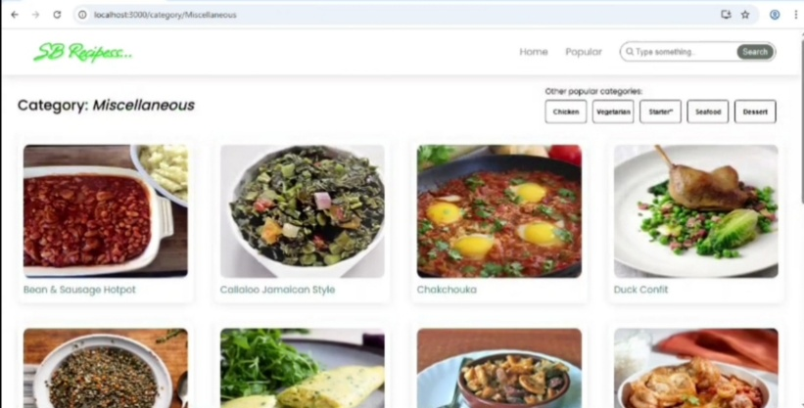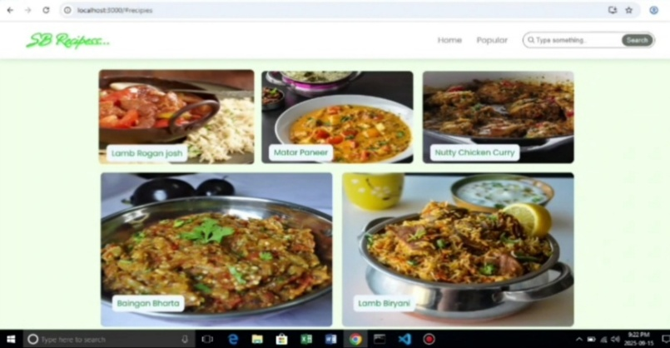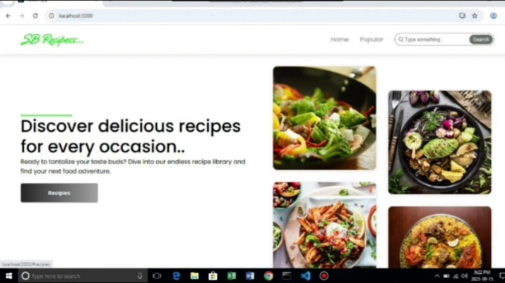***12. Screenshots or Demo***

***13. Known Issues***

*Slow loading for very large recipe images on low-end devices.*

*Timer notification sound may not play on Safari due to autoplay restrictions.*

***14. Future Enhancements***

*Add voice guidance for hands-free cooking.*

*Allow users to upload their own recipes.*

*Integration with smart kitchen devices.*

*Offline mode for saved recipes.*